**Progress Report on 8 September 2015**

* **Cross-correlations: Rationale for subtraction of mean values**

Cross-correlation is a measure of similarity of two series as a function of the lag of one relative to the other (i.e. measuring the ***correlation*** between two series with varying lag)

Observing the ***derivation of correlation***, the most familiar measure of dependence between two quantities is the ***Pearson product-moment correlation coefficient***. It is obtained by dividing the ***covariance*** of the two variables by the product of their standard deviations.

In [probability theory](https://en.wikipedia.org/wiki/Probability_theory) and [statistics](https://en.wikipedia.org/wiki/Statistics), ***covariance*** is a measure of how much two [random variables](https://en.wikipedia.org/wiki/Random_variable) change together. If the greater values of one variable mainly correspond with the greater values of the other variable, and the same holds for the smaller values, i.e., the variables tend to show similar behavior, the covariance is positive.

The ***covariance*** between two [jointly distributed](https://en.wikipedia.org/wiki/Joint_distribution) [real](https://en.wikipedia.org/wiki/Real_number)-valued [random variables](https://en.wikipedia.org/wiki/Random_variable) X and Y with ***finite*** [***second moments***](https://en.wikipedia.org/wiki/Second_moment) is defined as[2]



In [mathematics](https://en.wikipedia.org/wiki/Mathematics), a ***moment is a specific quantitative measure***, used in both [mechanics](https://en.wikipedia.org/wiki/Mechanics) and [statistics](https://en.wikipedia.org/wiki/Statistics), of the ***shape of a set of points***.

The n-th moment of a real-valued continuous function f(x) of a real variable about a value c is



It is possible to define moments for [random variables](https://en.wikipedia.org/wiki/Random_variable) in a more general fashion than moments for real values. The moment of a function, without further explanation, usually refers to the above expression with c = 0.

***For the*** ***second and higher moments, the central moments (moments about the mean, with c being the mean) are usually used rather than the moments about zero, because they provide clearer information about the distribution's shape.***

* New Function Prototypes:
  + Updated extractionscript.m

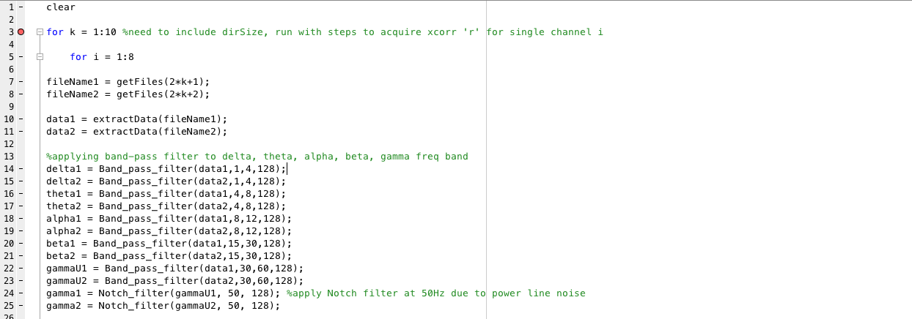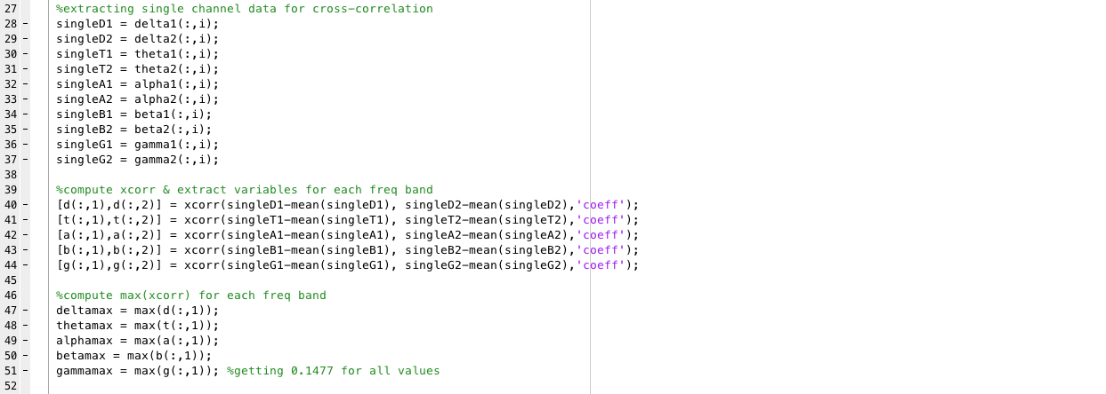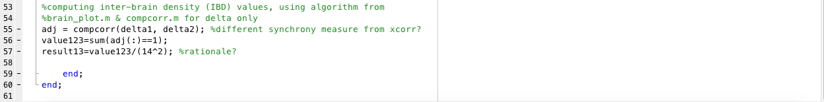

* + getFiles.m : to load files from chosen directory

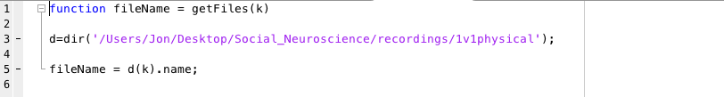

* + Notch_filter.m : to remove power line artefacts at 50Hz

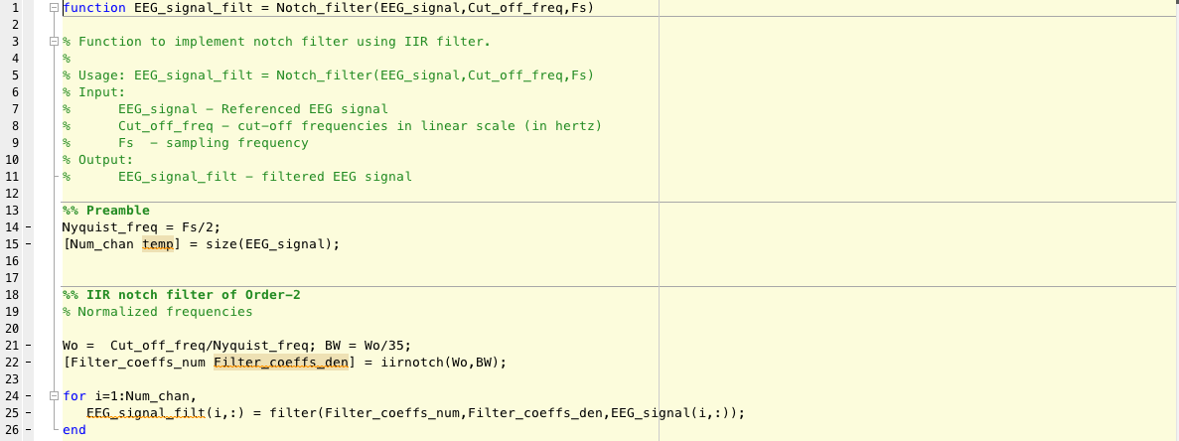

* Further Pre-processing Steps:
  + Sample data for reference:

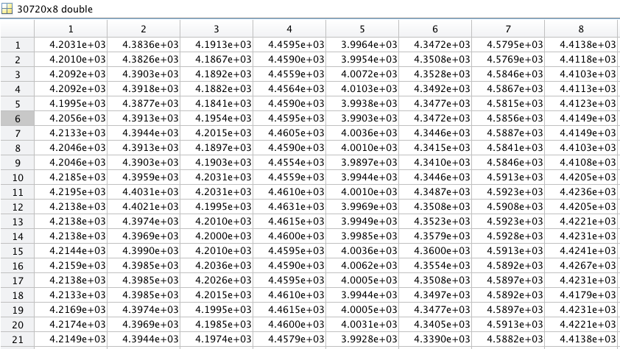

* + Referencing (Common Average):

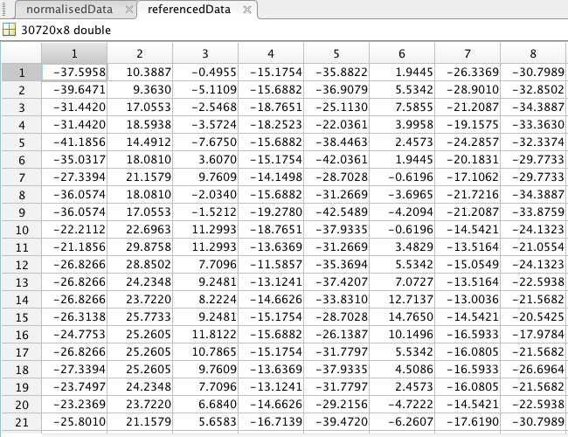

* + Normalisation:

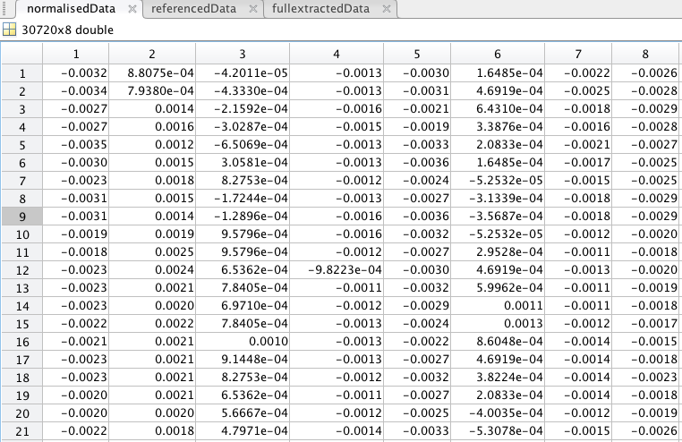

* Filtering
  + Band Pass filter (theta, alpha, beta, gamma with Notch Filter at 50Hz) sample code:

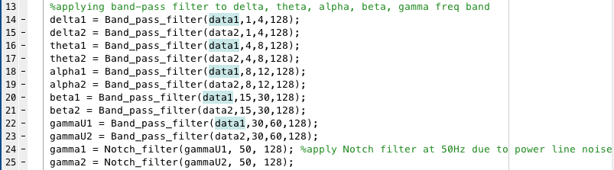

* Synchrony Measure — Matrix of inter-brain synchrony
  + Cross-Correlation: Max(xcorr); xcorr2

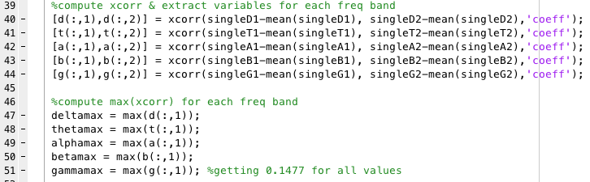

* Matrix of inter-brain synchrony —> Estimate Inter Brain density —> Single value representing IBD

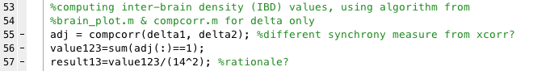

**Comments:**

* Need to determine rationale for IBD algorithm
* Future steps:
  + Statistical mean; Test for gaussianity
  + Compare p-values (ranks test) between scenarios